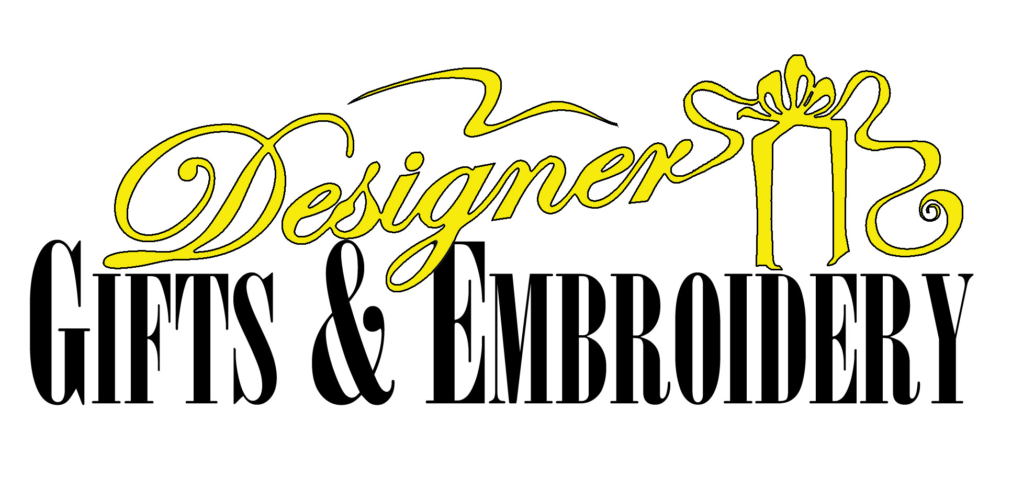
Your Image Is Our Business!
Helping you promote your image, your company, or your products is what we do!
When it comes to your wearables, your image is only as good as your supplier!
If your name or business logo appears on a golf shirt, tee, cap or jacket, you want to make sure it reflects the image of your first-rate business! When promoting your image, you must look your best!
We are a complete wearables provider, offering only the top brands of quality products as well as the highest quality sewn twill and embroidery available today!
- Port Authority
- IZOD
- Arnold Palmer
- Bill Blass Premium
- Van Heusen
- Outer Banks
- JERZEES & others!
Let us help you promote your image!

A Personalized Embroidery Gift Shop Offering High Quality Gifts and Corporate Promotional Products!

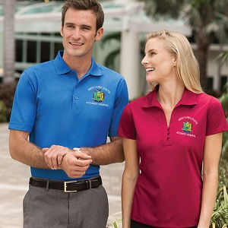

127 W. Main Street
Endicott, NY 13760
1-877-684-9572

